**SSN COLLEGE OF ENGINEERING, KALAVAKKAM  
DEPARTMENT OF COMPUTER SCIENCE AND ENGINEERING  
UCS1712 – GRAPHICS AND MULTIMEDIA LAB ------------------------------------------------------------------------------------------------------------**

**Lab Exercise 2 : DDA Line Drawing Algorithm in C++ using OpenGL**

**Aim:**

To perform DDA line drawing algorithm in C++ using OpenGL

**Algorithm:**

ProcedurelineDDA(xa,xb,ya,yb:integer);

Var

dx,dy,steps,k : integer;  
 xIncrement, yIncrement, x , y: real; Begin

dx:=xb-xa;  
 dy:=yb-ya;  
 ifabs(dx)>abs(dy)thensteps:=abs(dx) elsesteps:=abs(dy)  
 xIncrement:=dx/steps;  
 yIncrement:=dy/steps;  
 x:=xa;  
 y:=ya;

setPixel(round(x),round(y),1); fork:=1 to steps do  
 Begin

x:=x+xIncrement;  
 y:=y+yIncrement;  
 setPixel(round(x), round(y),1); End

End {lineDDA}

**To plot points that make up the line with endpoints (x0,y0) and (xn,yn) using the DDA line drawing algorithm.**

Case 1: +ve slope Left to Right line  
Case 2: +ve slope Right to Left line  
Case 3: -ve slope Left to Right line

Case 4: -ve slope Right to Left line

Each case has two subdivisions -

**(i) |m|<= 1 (ii) |m|>1  
Note that all four cases of line drawing must be given as test cases.**

***Source Code:***

#include<GLUT/glut.h>

#include<iostream>

#include<cmath>

#include<string>

using namespace std;

void drawString(float x, float y, const char *string){

glRasterPos2f(x, y);

for(const char* c = string;*c!='\0';c++)

glutBitmapCharacter(GLUT_BITMAP_HELVETICA_12, *c);

}

void myInit() {

glClearColor(1.0,0.6,0.5,0.0);

glPointSize(1);

glMatrixMode(GL_PROJECTION);

glLoadIdentity();

gluOrtho2D(0.0,480.0,0.0,480.0);

}

void myDisplay() {

glClear(GL_COLOR_BUFFER_BIT);

int x1,y1,x2,y2,dx,dy,choice;

float x,y;

cout<<"Enter 1 for L->R (or) 2 for R->L : ";

cin>>choice;

cout<<"Enter x1, y1, x2, y2: ";

cin>>x1>>y1>>x2>>y2;

glColor3f(0.0,0.0,0.0);

glBegin(GL_POINTS);

glVertex2f(x1,y1);

glEnd();

dx=x2-x1;

dy=y2-y1;

float m=(float)dy/dx;

cout<<"Slope = "<<m<<endl;

/* Positive Slope L->R */

if(choice==1 && m>=0.0){

x=x1;

y=y1;

if(abs(m)<=1.0){

while(x!=x2){

y=y+m;

x+=1;

glBegin(GL_POINTS);

glVertex2f(x,round(y));

glEnd();

}

}

else{

while(y!=y2){

x=x+(1/m);

y+=1;

glBegin(GL_POINTS);

glVertex2f(round(x),y);

glEnd();

}

}

}

/* Positive Slope R->L */

else if(choice==2 && m>=0){

x=x2;

y=y2;

if(abs(m)<=1.0){

while(x!=x1){

y=y-m;

x-=1;

glBegin(GL_POINTS);

glVertex2f(x,round(y));

glEnd();

}

}

else{

while(y!=y1){

x=x-(1/m);

y-=1;

glBegin(GL_POINTS);

glVertex2f(round(x),y);

glEnd();

}

}

}

/* Negative Slope L->R */

else if(choice==1 && m<0){

x=x1;

y=y1;

if(abs(m)<=1.0){

while(x!=x2){

y=y-abs(m);

x+=1;

glBegin(GL_POINTS);

glVertex2f(x,round(y));

glEnd();

}

}

else{

while(y!=y2){

x=x+(1/m);

y-=1;

glBegin(GL_POINTS);

glVertex2f(round(x),y);

glEnd();

}

}

}

/* Negative Slope R->L */

else if(choice==2 && m<0){

x=x2;

y=y2;

if(abs(m)<=1.0){

while(x!=x1){

y=y+abs(m);

x-=1;

glBegin(GL_POINTS);

glVertex2f(x,round(y));

glEnd();

}

}

else{

while(y!=y1){

x=x-abs(1/m);

y+=1;

glBegin(GL_POINTS);

glVertex2f(round(x),y);

glEnd();

}

}

}

drawString(x1,y1,("("+to_string(x1)+","+to_string(y1)+")").c_str());

drawString(x2,y2,("("+to_string(x2)+","+to_string(y2)+")").c_str());

glFlush();

}

int main(int argc,char* argv[]) {

glutInit(&argc,argv);

glutInitDisplayMode(GLUT_SINGLE|GLUT_RGB);

glutInitWindowSize(480,480);

glutCreateWindow("DDA Algorithm");

glutDisplayFunc(myDisplay);

myInit();

glutMainLoop();

return 1;

}

***Output:***

***Case 1: +ve slope Left to Right line***

***m>1***

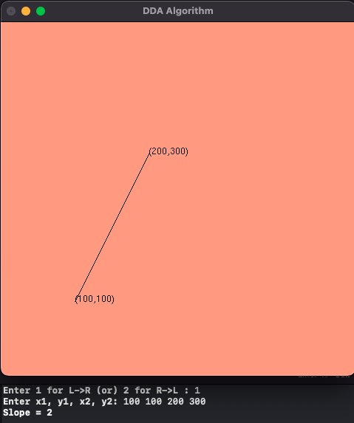

***m<=1***

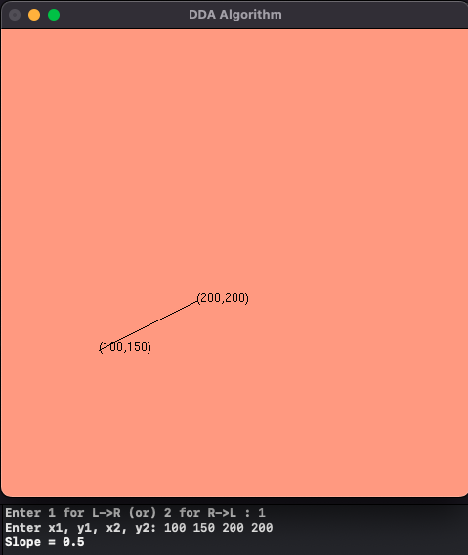

***Case 2: +ve slope Right to Left line***

***m>1***

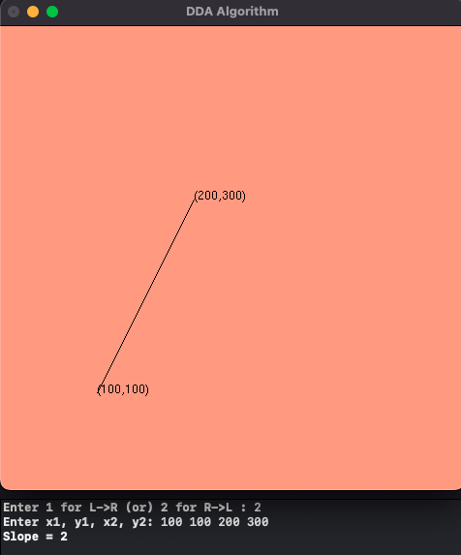

**m<=1**

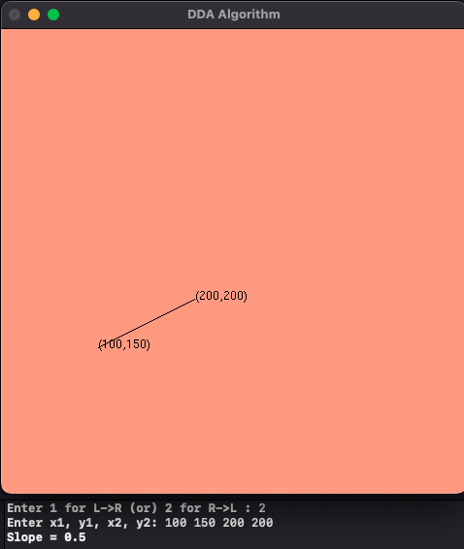

**Case 3: -ve slope Left to Right line**

**m>1**

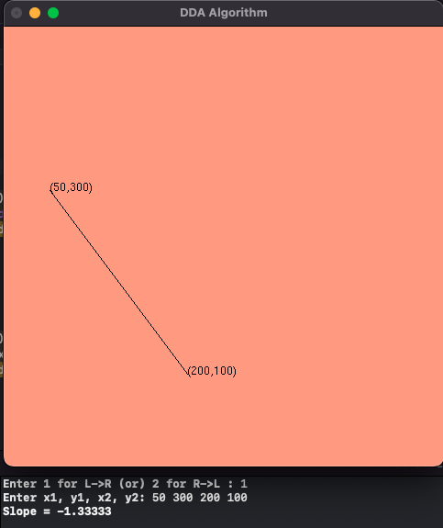

**m<=1**

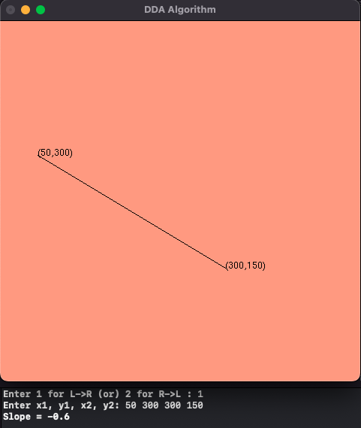

**Case 4: -ve slope Right to Left line**

**m>1**

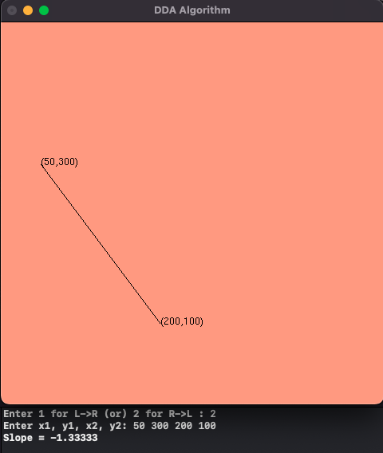

**m<=1**

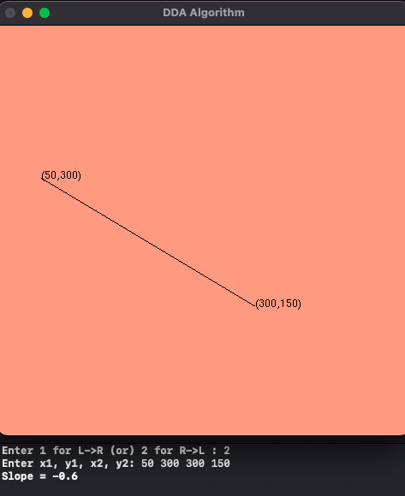

**Learning Outcome;**

Learnt how to perform DDA algorithm in C++ using OpenGL